Expt. 1

library IEEE;
use IEEE.STD_LOGIC_1164.ALL;

entity fa is
Port ( a : in STD_LOGIC; b : in STD_LOGIC;
cin : in STD_LOGIC; s : out STD_LOGIC; co : out STD_LOGIC);
end fa;
architecture Behavioral of fa is begin
s <= a xor b xor cin;
co <= (a and b) or (b and cin) or (a and cin); end Behavioral;

LIBRARY ieee;
USE ieee.std_logic_1164.ALL;

ENTITY fa_tb IS END fa_tb;

ARCHITECTURE behavior OF fa_tb IS
-- Component Declaration for the Unit Under Test (UUT) COMPONENT fa
PORT(
- : IN std_logic;
- : IN std_logic; cin : IN std_logic; s : OUT std_logic; co : OUT std_logic
);
END COMPONENT;

--Inputs
signal a : std_logic := '0'; signal b : std_logic := '0'; signal cin : std_logic := '0';

--Outputs signal s : std_logic;
signal co : std_logic;
-- No clocks detected in port list. Replace <clock> below with
-- appropriate port name BEGIN
-- Instantiate the Unit Under Test (UUT) uut: fa PORT MAP (
a => a,
b => b,
cin => cin, s => s,
co => co
);
-- Stimulus process stim_proc: process begin
a <= '0';
b <= '0';
cin <= '0'; wait for 20 ns;
a <= '0';

b <= '1';
cin <= '0'; wait for 20 ns;
a <= '1';
b <= '0';
cin <= '1'; wait for 20 ns;
a <= '1';
b <= '1';
cin <= '1'; wait for 20 ns;
end process; END;

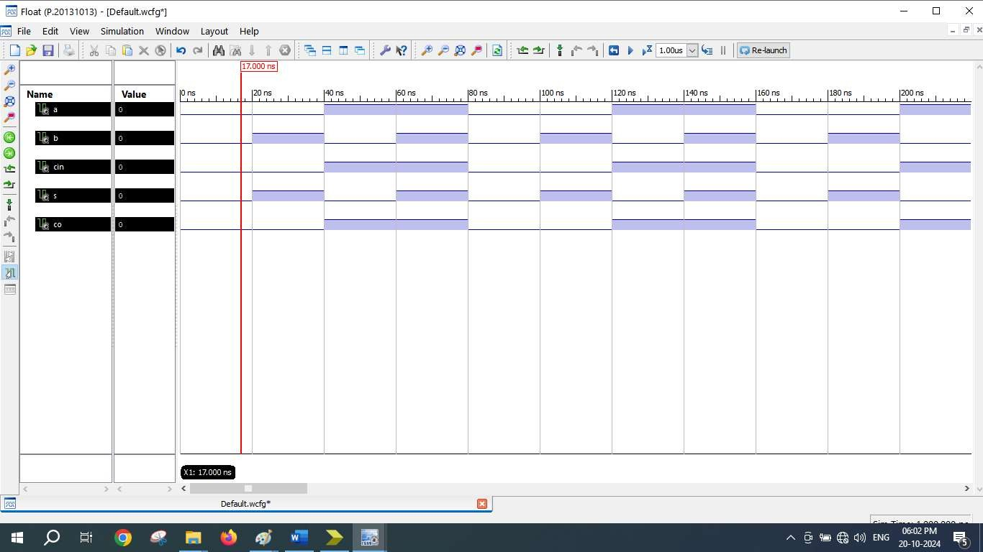

=========================================================================
* Final Report *
=========================================================================
Final Results
RTL Top Level Output File Name : fa.ngr Top Level Output File Name : fa
Output Format : NGC
Optimization Goal : Speed
Keep Hierarchy : No

Design Statistics
# IOs : 5

Cell Usage :
# BELS : 2
# LUT3 : 2
# IO Buffers : 5
# IBUF : 3
# OBUF : 2
=========================================================================

Device utilization summary:

Selected Device : 3s250epq208-5

Number | of | Slices: | 1 | out | of | 2448 | 0%
Number | of | 4 input LUTs: | 2 | out | of | 4896 | 0%
Number | of | IOs: | 5
Number | of | bonded IOBs: | 5 | out | of | 158 | 3%

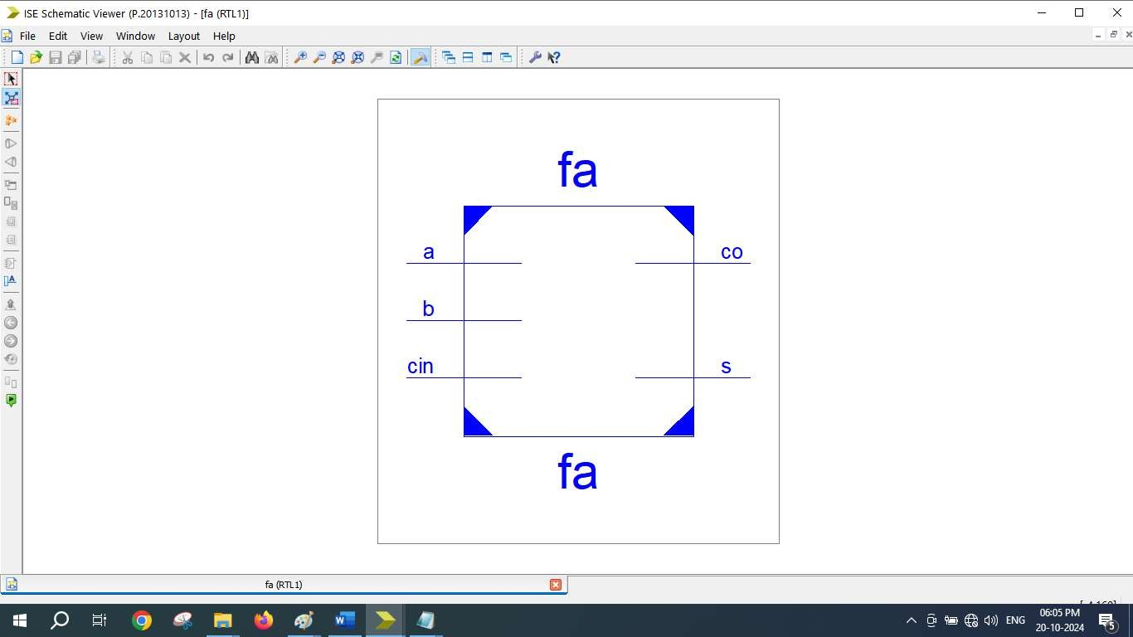

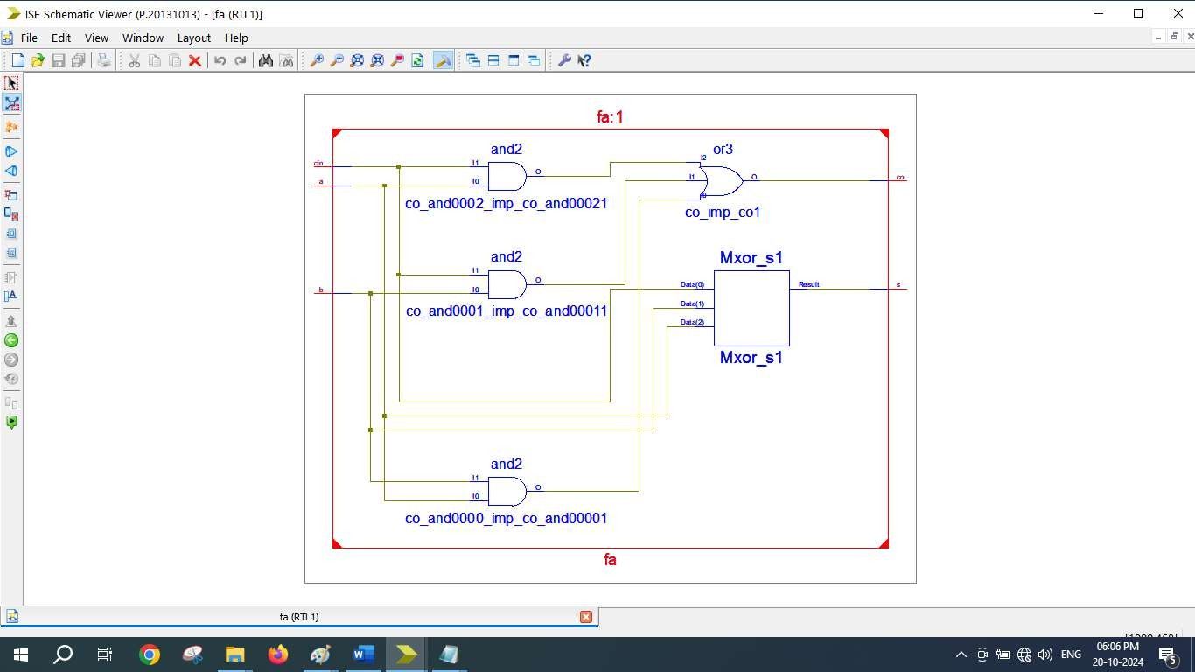

Expt. 2

library IEEE;
use IEEE.STD_LOGIC_1164.ALL; use IEEE.STD_LOGIC_ARITH.ALL;
use IEEE.STD_LOGIC_UNSIGNED.ALL;

entity ALU_4bit is
Port ( a : in STD_LOGIC_VECTOR (3 downto 0); b : in STD_LOGIC_VECTOR (3 downto 0); sel : in STD_LOGIC_VECTOR (2 downto 0); y : out STD_LOGIC_VECTOR (3 downto 0));
end ALU_4bit;
architecture Behavioral of ALU_4bit is begin
process (a, b, sel) begin
case sel is
when "000" => y <= a + b; when "001" => y <= a - b; when "010" => y <= b - a; when "011" => y <= a and b; when "100" => y <= a or b; when "101" => y <= a nand b; when "110" => y <= a xor b; when "111" => y <= a nor b; when others => null;
end case; end process;
end Behavioral;

LIBRARY ieee;
USE ieee.std_logic_1164.ALL;

ENTITY ALU_TB IS END ALU_TB;

ARCHITECTURE behavior OF ALU_TB IS
-- Component Declaration for the Unit Under Test (UUT) COMPONENT ALU_4bit
PORT(
- : IN std_logic_vector(3 downto 0);
- : IN std_logic_vector(3 downto 0); sel : IN std_logic_vector(2 downto 0); y : OUT std_logic_vector(3 downto 0)
);
END COMPONENT;

--Inputs
signal a : std_logic_vector(3 downto 0) := (others => '0'); signal b : std_logic_vector(3 downto 0) := (others => '0'); signal sel : std_logic_vector(2 downto 0) := (others => '0');

--Outputs
signal y : std_logic_vector(3 downto 0);
-- No clocks detected in port list. Replace <clock> below with
-- appropriate port name BEGIN
-- Instantiate the Unit Under Test (UUT) uut: ALU_4bit PORT MAP (
a => a,
b => b,
sel => sel, y => y
);

-- Stimulus process stim_proc: process begin
a <= "1010";
b <= "0101";
sel <= "000";
wait for 10 ns; sel <= "001";
wait for 10 ns; sel <= "010";

wait for 10 ns; sel <= "011";
wait for 10 ns; sel <= "100";
wait for 10 ns; sel <= "101";
wait for 10 ns; sel <= "110";
wait for 10 ns; sel <= "111";
wait for 10 ns;

end process; END;

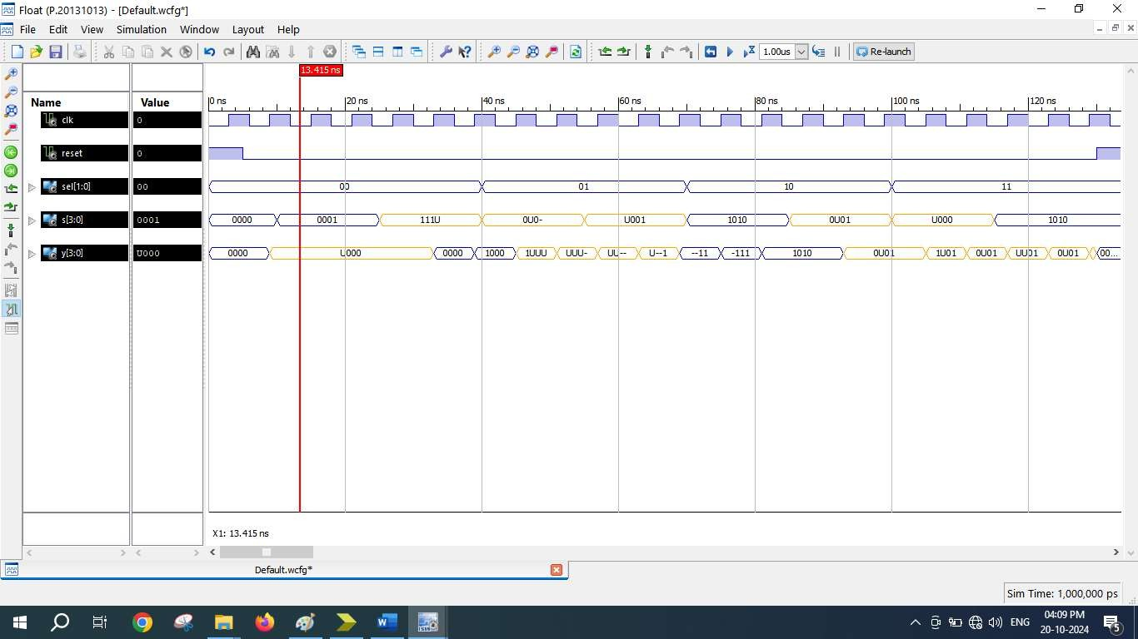

=========================================================================
* Final Report *
=========================================================================
Final Results
RTL Top Level Output File Name : ALU_4bit.ngr Top Level Output File Name : ALU_4bit
Output Format : NGC
Optimization Goal : Speed
Keep Hierarchy : No

Design Statistics
# IOs : 15

Cell Usage :
# BELS : 30
# INV : 1
# LUT2 : 2
# LUT3 : 2
# LUT4 : 18
# MUXF5 : 7
# IO Buffers : 15
# IBUF : 11
# OBUF : 4
=========================================================================

Device utilization summary:

Selected Device : 3s250epq208-5

Number | of | Slices: | 13 | out | of | 2448 | 0%
Number | of | 4 input LUTs: | 23 | out | of | 4896 | 0%
Number | of | IOs: | 15
Number | of | bonded IOBs: | 15 | out | of | 158 | 9%

Partition Resource Summary:

No Partitions were found in this design.

=========================================================================

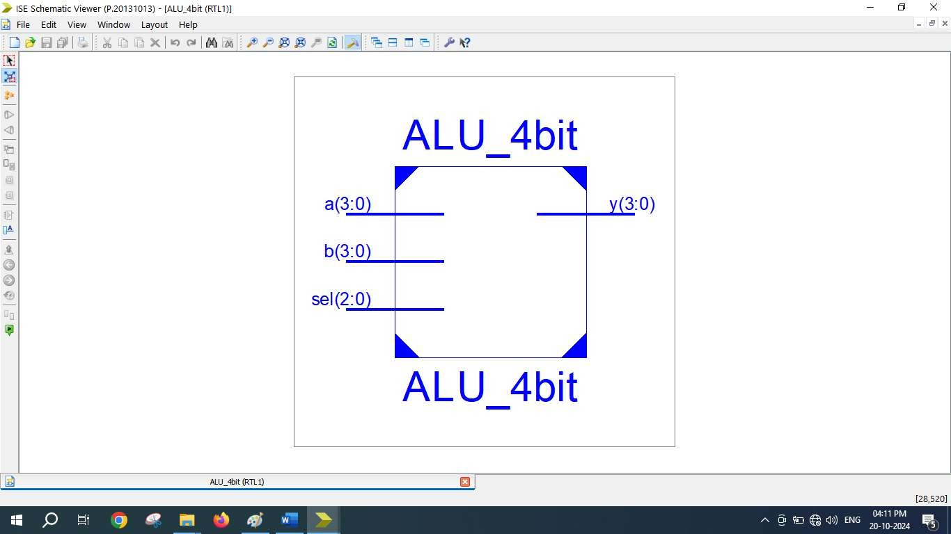

Expt. 3

library IEEE;
use IEEE.STD_LOGIC_1164.ALL;

entity shiftregister is
Port( clk,rst : in std_logic;
s : in std_logic_vector(3 downto 0);
m : in std_logic_vector(1 downto 0); -- mode y : out std_logic_vector(3 downto 0) );
end shiftregister;

architecture Behavioral of shiftregister is signal t : std_logic_vector(3 downto 0);

begin

process(clk, rst) begin

if rst = '1' then
y <= "0000";
elsif clk'event and clk = '1' then case m is
when "00" => -- SISO
t(3) <= s(0); -- LSB as input S(0) t(2) <= t(3);
t(1) <= t(2);
t(0) <= t(1);
y(0) <= t(0); -- LSB as output Y(0)

when "01" => -- SIPO
t(3) <= s(0); -- LSB as input S(0) t(2) <= t(3);
t(1) <= t(2);
t(0) <= t(1);
y <= t; -- parallel output

when "10" => -- PIPO
t <= s; y <= t;

when "11" => -- PISO
t <= s; -- 4 bit input S & t <= s
t(2) <= t(3); -- MSB input as t(3) <= S(3)

S(3)

end if; end process;
t(1) <= t(2);
t(0) <= t(1);
y(3) <= t(0); -- MSB as output Y(3) <=

when others => NULL; end case;

end Behavioral;

LIBRARY ieee;
USE ieee.std_logic_1164.ALL;

ENTITY usr2_tb IS END usr2_tb;
ARCHITECTURE behavior OF usr2_tb IS COMPONENT shiftregister
PORT(
clk : IN std_logic; rst : IN std_logic;
s : IN std_logic_vector(3 downto 0); m : IN std_logic_vector(1 downto 0); y : OUT std_logic_vector(3 downto 0)
);
END COMPONENT;

-- Inputs
signal clk : std_logic := '0'; signal rst : std_logic := '0';
signal s : std_logic_vector(3 downto 0) := (others => '0'); signal m : std_logic_vector(1 downto 0) := (others => '0');

-- Outputs
signal y : std_logic_vector(3 downto 0); BEGIN
-- Instantiate the Unit Under Test (UUT) uut: shiftregister PORT MAP (
clk => clk, rst => rst, s => s,
m => m, y => y
);

-- Clock process definitions clk_process : process
begin

end process;
clk <= '0'; wait for 3 ns; clk <= '1'; wait for 3 ns;

-- Stimulus process stim_proc: process begin

rst <= '1'; wait for 5 ns;
rst <= '0'; wait for 5 ns;

-- Test SISO Mode m <= "00";
s <= "1-0U";
wait for 50 ns;

-- Test SIPO Mode m <= "01";
s <= "1UXX";
wait for 50 ns;

-- Test PISO Mode m <= "11";
s <= "1111";
wait for 50 ns;

-- Test PIPO Mode m <= "10";
s <= "1UU0";
wait for 50 ns; end process;
END;

Output for SISO and SIPO

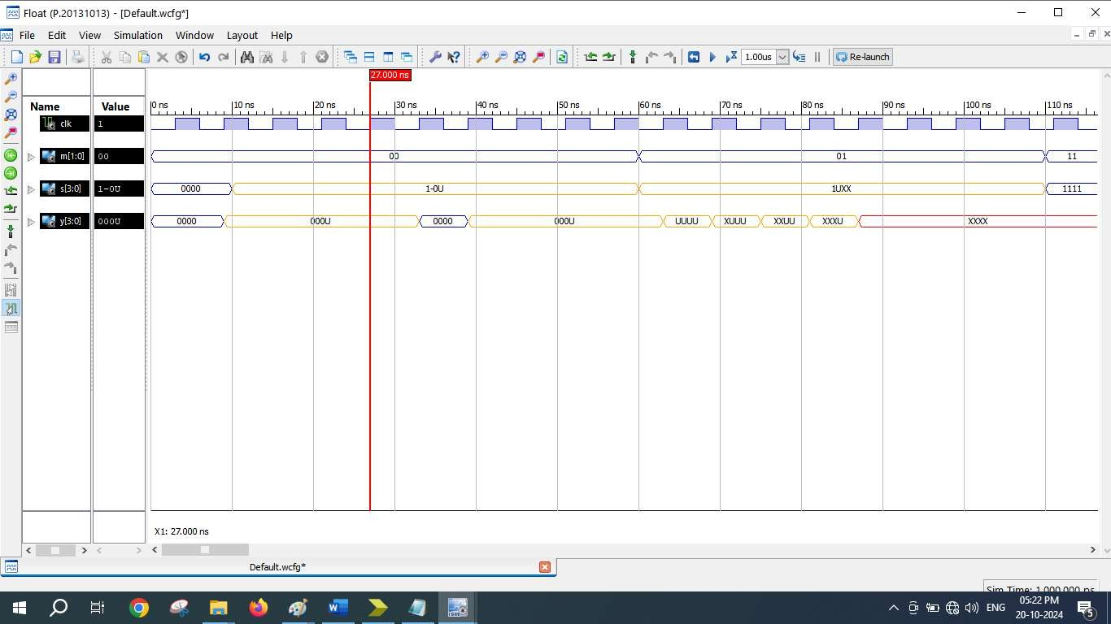

Output for PISO and PIPO
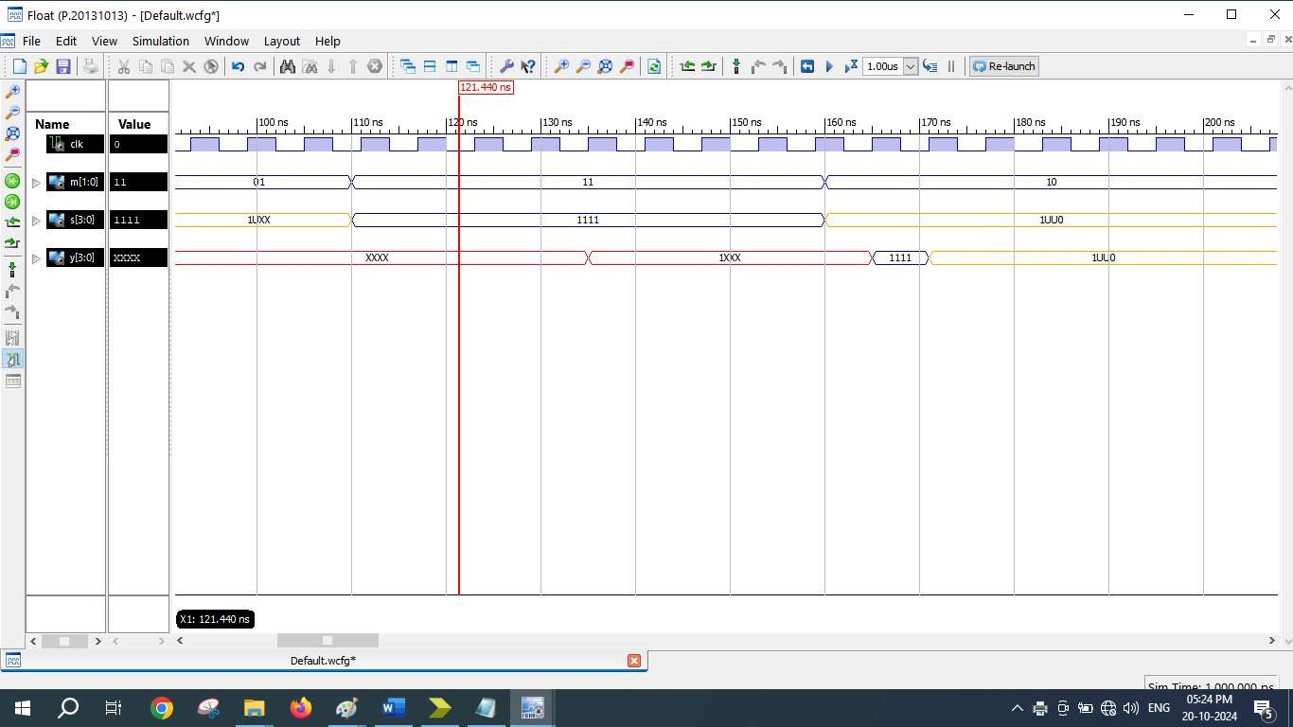

=========================================================================
* Final Report *
=========================================================================
Final Results
RTL Top Level Output File Name : shiftregister.ngr Top Level Output File Name : shiftregister Output Format : NGC
Optimization Goal : Speed
Keep Hierarchy : No
Design Statistics
# IOs : 12
Cell Usage :
# BELS : 11
# INV : 1
# LUT3 : 3
# LUT3_L : 2
# LUT4 : 5
# FlipFlops/Latches : 8
# FDC : 4
# FDE : 4
# Clock Buffers : 1
# BUFGP : 1
# IO Buffers : 11
# IBUF : 7
# OBUF : 4
=========================================================================
Device utilization summary:
‐‐‐‐‐‐‐‐‐‐‐‐‐‐‐‐‐‐‐‐‐‐‐‐‐‐‐
Selected Device : 3s250epq208‐5

Number | of | Slices: | 5 | out | of | 2448 | 0%
Number | of | Slice Flip Flops: | 8 | out | of | 4896 | 0%
Number | of | 4 input LUTs: | 11 | out | of | 4896 | 0%
Number | of | IOs: | 12
Number | of | bonded IOBs: | 12 | out | of | 158 | 7%
Number | of | GCLKs: | 1 | out | of | 24 | 4%

‐‐‐‐‐‐‐‐‐‐‐‐‐‐‐‐‐‐‐‐‐‐‐‐‐‐‐
Partition Resource Summary:
‐‐‐‐‐‐‐‐‐‐‐‐‐‐‐‐‐‐‐‐‐‐‐‐‐‐‐
No Partitions were found in this design.
‐‐‐‐‐‐‐‐‐‐‐‐‐‐‐‐‐‐‐‐‐‐‐‐‐‐‐

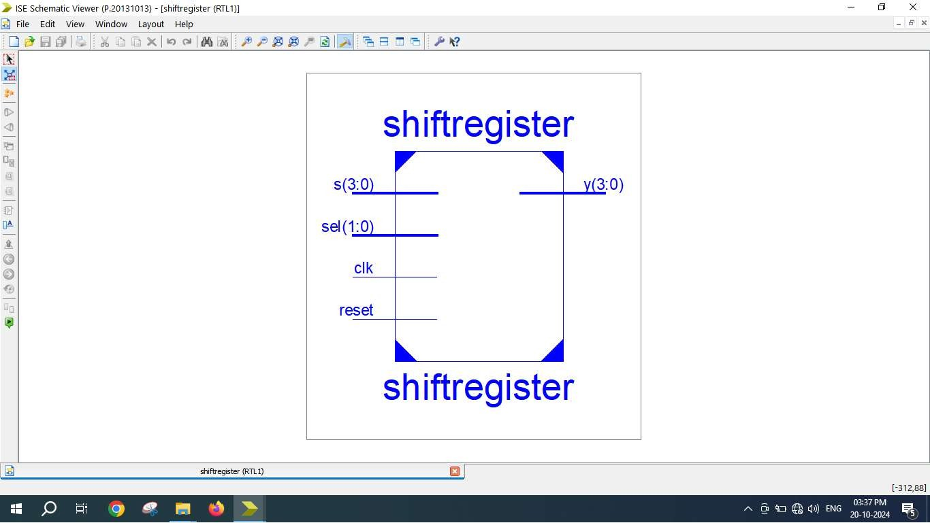

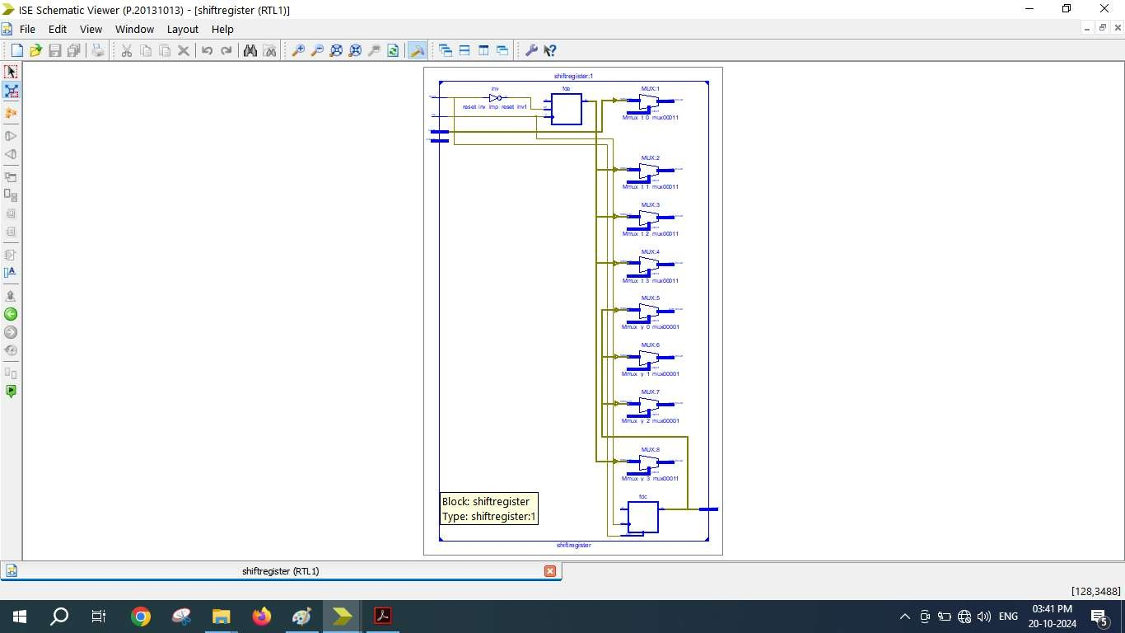

Expt. 4

-- Modulo-10 Counter with Synchronous Reset : 0 to 9 (0000 to 1001) library IEEE;
use IEEE.std_logic_1164.all;
use IEEE.std_logic_unsigned.all;

entity counter is
port ( CLK : in std_logic;
RST : in std_logic; -- Synchronous reset input RST active

high

end counter;

Q : out std_logic_vector(3 downto 0));

architecture counter_arch of counter is signal TEMP_Q : std_logic_vector(3 downto 0); begin
process(CLK) begin
if rising_edge(CLK) then -- if clk'event and clk = '1' then
if RST = '1' then -- active high and it is inside clock therfore its synchronous reset
TEMP_Q <= (others => '0'); -- TEMP_Q <= "0000"
else
if (TEMP_Q = "1001") then
TEMP_Q <= (others => '0'); -- TEMP_Q <= "0000"
else
TEMP_Q <= TEMP_Q + 1; -- up counting end if ;
end if ; end if;
end process; Q <= TEMP_Q;
end counter_arch;

LIBRARY ieee;
USE ieee.std_logic_1164.ALL;

ENTITY counter_tb IS END counter_tb;

ARCHITECTURE behavior OF counter_tb IS
-- Component Declaration for the Unit Under Test (UUT) COMPONENT counter
PORT(
CLK : IN std_logic; RST : IN std_logic;
Q : OUT std_logic_vector(3 downto 0)
);
END COMPONENT;

--Inputs
signal CLK : std_logic := '0'; signal RST : std_logic := '0';

--Outputs
signal Q : std_logic_vector(3 downto 0);

-- Clock period definitions BEGIN

-- Instantiate the Unit Under Test (UUT) uut: counter PORT MAP (
CLK => CLK, RST => RST, Q => Q
);

-- Clock process definitions CLK_process :process
begin

end process;
CLK <= '0';
wait for 5 ns; CLK <= '1';
wait for 5 ns;

-- Stimulus process stim_proc: process begin
-- hold reset state for 100 ns.

RST | <= | '1';
 |  | wait | for | 20 ns;
RST | <= | '0';
 |  | wait | for | 200 ns;
RST | <= | '1';
 |  | wait | for | 10 ns;
RST | <= | '0';
 |  | wait | for | 300 ns;
end process; END;

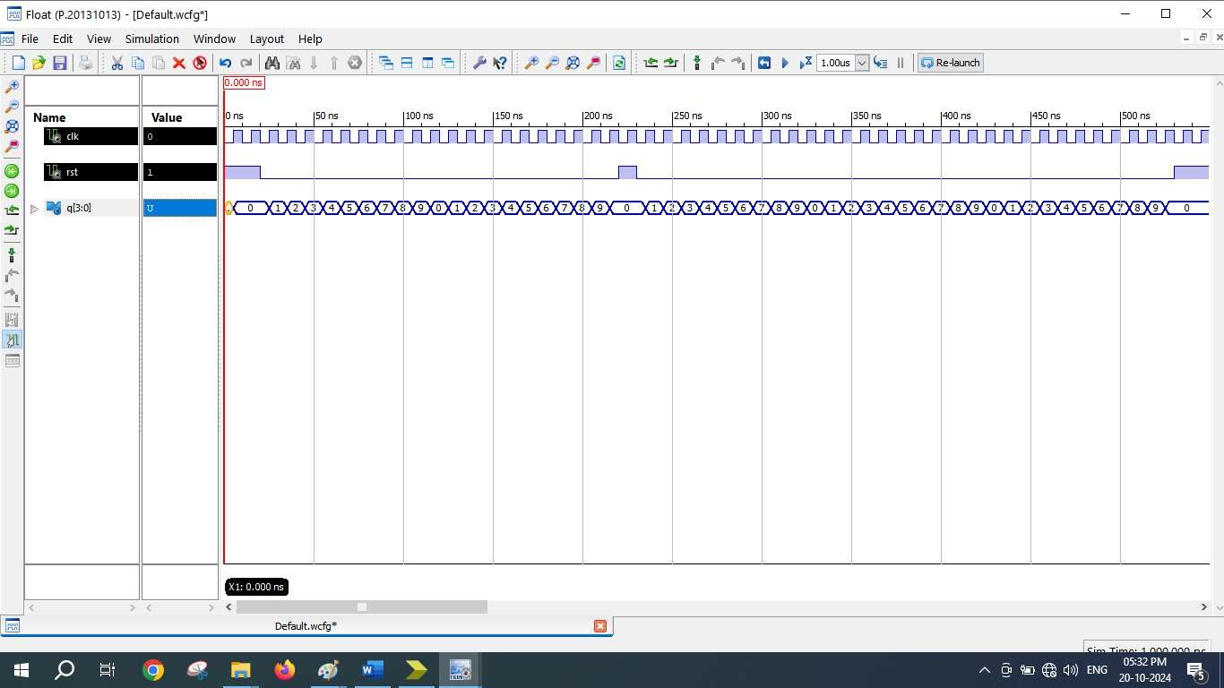

=========================================================================
* Final Report *
=========================================================================
Final Results
RTL Top Level Output File Name : counter.ngr Top Level Output File Name : counter
Output Format : NGC
Optimization Goal : Speed
Keep Hierarchy : No

Design Statistics
# IOs : 6

Cell Usage :
# BELS : 6
# INV : 1
# LUT2 : 1
# LUT2_L : 1
# LUT3 : 1
# LUT4 : 2
# FlipFlops/Latches : 4
# FDR : 4
# Clock Buffers : 1
# BUFGP : 1
# IO Buffers : 5
# IBUF : 1
# OBUF : 4
=========================================================================

Device utilization summary:

Selected Device : 3s250epq208-5

Number | of | Slices: | 3 | out | of | 2448 | 0%
Number | of | Slice Flip Flops: | 4 | out | of | 4896 | 0%
Number | of | 4 input LUTs: | 6 | out | of | 4896 | 0%
Number | of | IOs: | 6
Number | of | bonded IOBs: | 6 | out | of | 158 | 3%
Number | of | GCLKs: | 1 | out | of | 24 | 4%

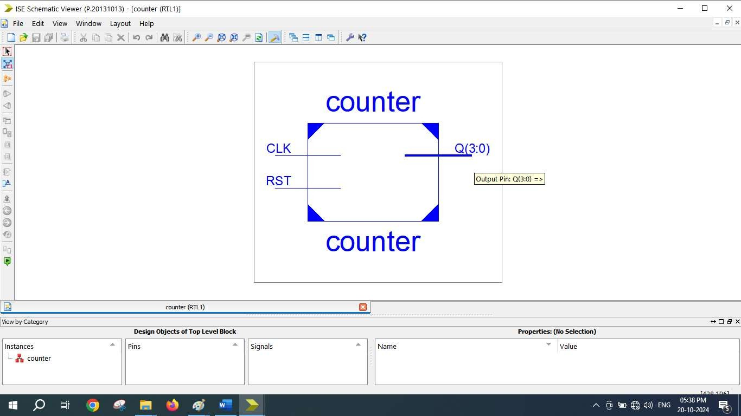

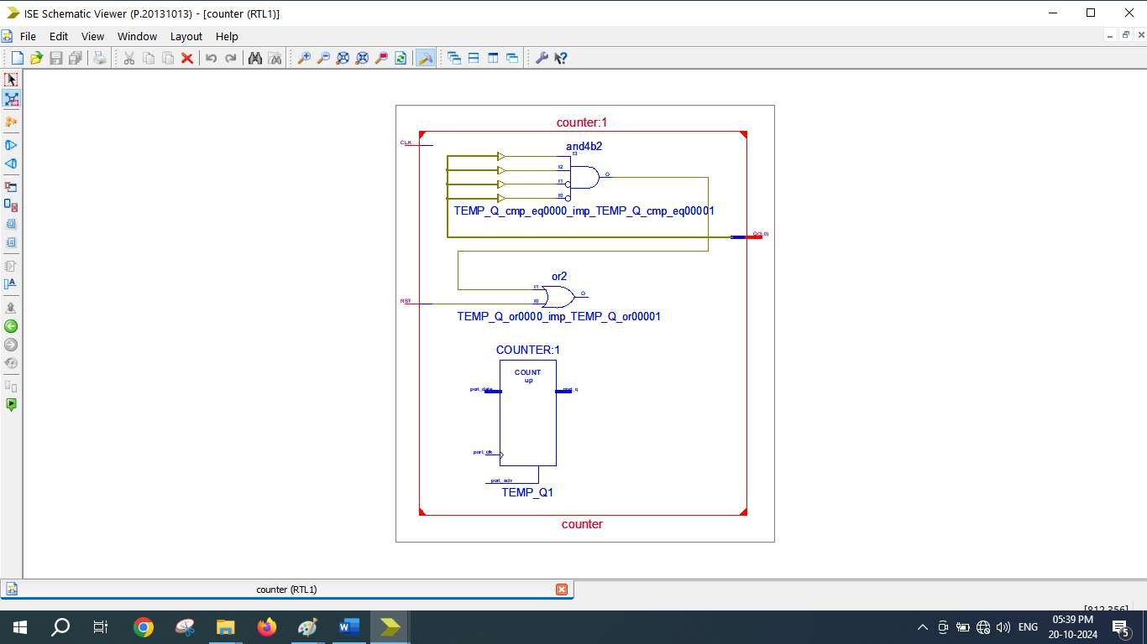

Expt. 5

library IEEE;
use IEEE.STD_LOGIC_1164.ALL;
use IEEE.STD_LOGIC_unsigned.ALL; use IEEE.STD_LOGIC_arith.ALL;

-- Uncomment the following library declaration if using
-- arithmetic functions with Signed or Unsigned values
--use IEEE.NUMERIC_STD.ALL;

-- Uncomment the following library declaration if instantiating
-- any Xilinx primitives in this code.
--library UNISIM;
--use UNISIM.VComponents.all;

entity FIFO_4bit is
Port ( clk,rst : in STD_LOGIC; enr,enw : in STD_LOGIC;
datain : in STD_LOGIC_VECTOR (3 downto 0); dataout : out STD_LOGIC_VECTOR (3 downto 0); full,empty : out STD_LOGIC);
end FIFO_4bit;

architecture Behavioral of FIFO_4bit is

type memory_type is array (0 to 7) of std_logic_vector(3 downto 0); signal memory : memory_type;
signal readptr,writeptr : std_logic_vector(3 downto 0):="0000";

--signal cnt:std_logic_vector(24 downto 0);

--signal clk1:std_logic;
begin

FIFO_Process: process(clk)

begin

if(clk'event and clk='1' and enw ='1' and enr='0') then --WRITE
OPERATION

memory(conv_integer(writeptr)) <= datain; writeptr <= writeptr + '1';
end if;

if(clk'event and clk='1' and enr ='1' and enw='0') then --READ
OPERATION

dataout <= memory(conv_integer(readptr));

readptr <= readptr + '1';
end if;

if(readptr = "1000") then

empty<='1';

else

empty<='0';

end if;

if(writeptr = "1000") then

full <='1';

else

full <='0';
end if; end process;
end Behavioral;

LIBRARY ieee;
USE ieee.std_logic_1164.ALL;

-- Uncomment the following library declaration if using
-- arithmetic functions with Signed or Unsigned values
--USE ieee.numeric_std.ALL;

ENTITY test1 IS END test1;

ARCHITECTURE behavior OF test1 IS
-- Component Declaration for the Unit Under Test (UUT) COMPONENT FIFO_4bit
PORT(
clk : IN std_logic; rst : IN std_logic; enr : IN std_logic; enw : IN std_logic;
datain : IN std_logic_vector(3 downto 0); dataout : OUT std_logic_vector(3 downto 0); full : OUT std_logic;
empty : OUT std_logic
);
END COMPONENT;

--Inputs
signal clk : std_logic := '0'; signal rst : std_logic := '0'; signal enr : std_logic := '0'; signal enw : std_logic := '0';
signal datain : std_logic_vector(3 downto 0) := (others => '0');

--Outputs
signal dataout : std_logic_vector(3 downto 0); signal full : std_logic;
signal empty : std_logic;

-- Clock period definitions
constant clk_period : time := 10 ns; BEGIN
-- Instantiate the Unit Under Test (UUT) uut: FIFO_4bit PORT MAP (
clk => clk, rst => rst, enr => enr,

enw => enw, datain => datain,
dataout => dataout, full => full,
empty => empty
);

-- Clock process definitions clk_process :process
begin

end process;
clk <= '1'; wait for 5 ns; clk <= '0'; wait for 5 ns;

-- Stimulus process stim_proc: process begin

enw<='1';
enr<='0'; datain<="0001"; wait for 10ns;

datain<="0011"; wait for 10ns;

datain<="0111"; wait for 10ns;

datain<="1111"; wait for 10ns;

datain<="1110"; wait for 10ns;

datain<="1100"; wait for 10ns;

datain<="1000"; wait for 10ns;

datain<="0000"; wait for 10ns;

enw<='0';
enr<='1';
wait for 80ns;

end process; END;

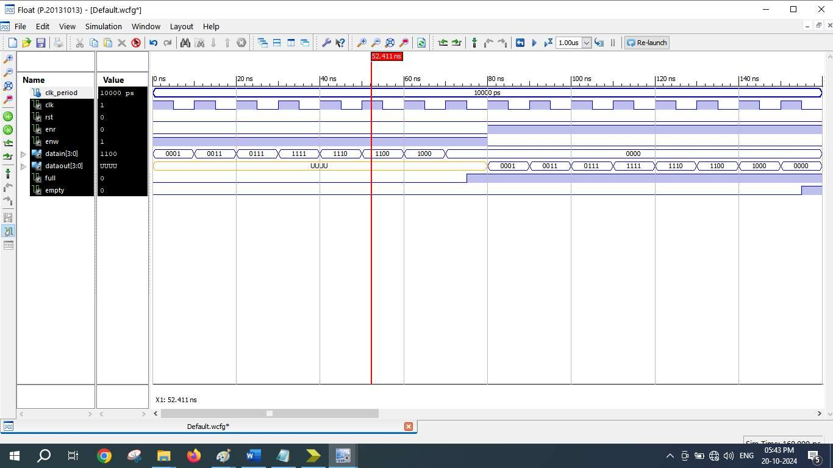

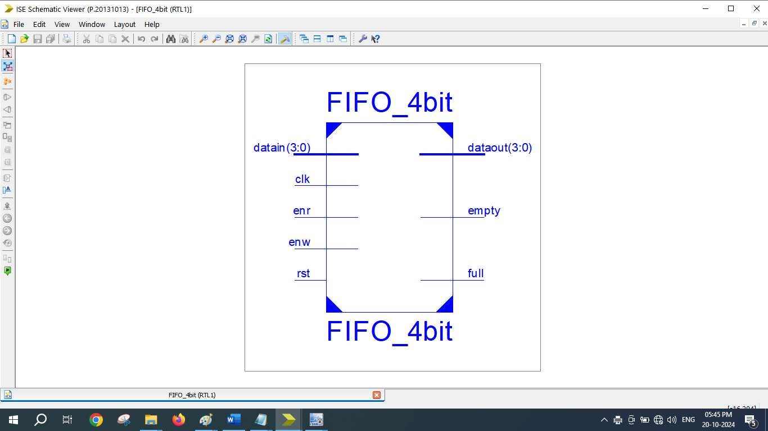

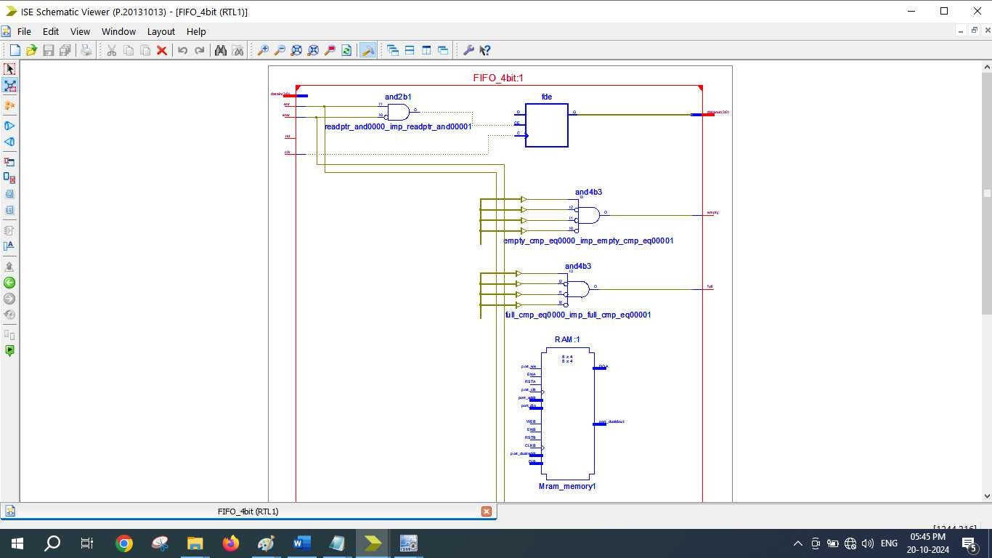

=========================================================================
* Final Report *
=========================================================================
Final Results
RTL Top Level Output File Name : FIFO_4bit.ngr Top Level Output File Name : FIFO_4bit Output Format : NGC
Optimization Goal : Speed
Keep Hierarchy : No

Design Statistics
# IOs : 14

Cell Usage :
# BELS : 13
# GND : 1
# INV : 2
# LUT2 : 4
# LUT3 : 2
# LUT4 : 4
# FlipFlops/Latches : 12
# FDE : 12
# RAMS : 4
# RAM16X1D : 4
# Clock Buffers : 1
# BUFGP : 1
# IO Buffers : 12
# IBUF : 6
# OBUF : 6
=========================================================================

Device utilization summary:

Selected Device : 3s250epq208-5

Number | of | Slices: | 10 | out | of | 2448 | 0%
Number | of | Slice Flip Flops: | 12 | out | of | 4896 | 0%
Number | of | 4 input LUTs: | 20 | out | of | 4896 | 0%
Number used as logic: 12
Number used as RAMs: 8
Number | of | IOs: |  | 14
Number | of | bonded | IOBs: | 13 | out | of | 158 | 8%
Number | of | GCLKs: |  | 1 | out | of | 24 | 4%

Expt. 6

library IEEE;
use IEEE.STD_LOGIC_1164.ALL; use IEEE.STD_LOGIC_ARITH.ALL;
use IEEE.STD_LOGIC_UNSIGNED.ALL;
entity lcd is
Port ( clk,reset : in std_logic; RS,EN : out std_logic;
data : out std_logic_vector(7 downto 0));
end lcd;
architecture Behavioral of lcd is
type state_type is (s0,s1,s2,s3,s4,s5,s6,s7,s8,s9,s10,s11, s12,s13,s14,s15,s16,s17,s18,s19,s20,s21,s22,s23);
signal state:state_type; begin
process(clk, reset, state) begin
if reset = '1' then
state <= s0;
elsif rising_edge(clk) then if state = s0 then
state <= s1;
RS<='0'; -- Write commands to LCD. EN <= '1';
data <= "00110000"; -- Function set for 8 bit interface, 1 line mode and 5x7 dot matrix.
end if;
if state = s1 then
state <= s2; EN <= '0';

ON.
end if;
if state = s2 then
state <= s3; EN <= '1';
data <= "00001111"; -- Display cursor and blinking

end if;
if state = s3 then
state <= s4; EN <= '0';
end if;
if state = s4 then
state <= s5; EN <= '1';
data <= "00000001"; -- Clear display.
end if;
if state = s5 then
state <= s6; EN <= '0';
end if;
if state = s6 then

end if;
state <= s7; EN <= '1';
data <= "10000100"; -- Display address.

if state = s7 then
state <= s8; EN <= '0';
end if;
if state = s8 then
RS <= '1'; -- Write data to LCD. state <= s9;
EN <= '1';
data <= "01010111"; --W
end if;
if state = s9 then
state <= s10; EN <= '0';
end if;
if state = s10 then
state <= s11; EN <= '1';
data <= "01000101"; --E
end if;
if state = s11 then
state <= s12; EN <= '0';
end if;
if state = s12 then
state <= s13; EN <= '1';
data <= "01001100"; --L
end if;
if state = s13 then
state <= s14; EN <= '0';
end if;
if state = s14 then
state <= s15; EN <= '1';
data <= "10110000"; --(-)
end if;
if state = s15 then
state <= s16; EN <= '0';
end if;
if state = s16 then
state <= s17; EN <= '1';
data <= "01000011"; --C
end if;

if state = s17 then
state <= s18; EN <= '0';
end if;
if state = s18 then
state <= s19; EN <= '1';
data <= "01001111"; --O
end if;
if state = s19 then
state <= s20; EN <= '0';
end if;
if state = s20 then
state <= s21; EN <= '1';
data <= "01001101"; --M
end if;
if state = s21 then
state <= s22; EN <= '0';
end if;
if state = s22 then
state <= s23; EN <= '1';
data <= "01000101"; --E
end if;
if state = s23 then
EN <= '0';
end if;
end if; end process;
end Behavioral;

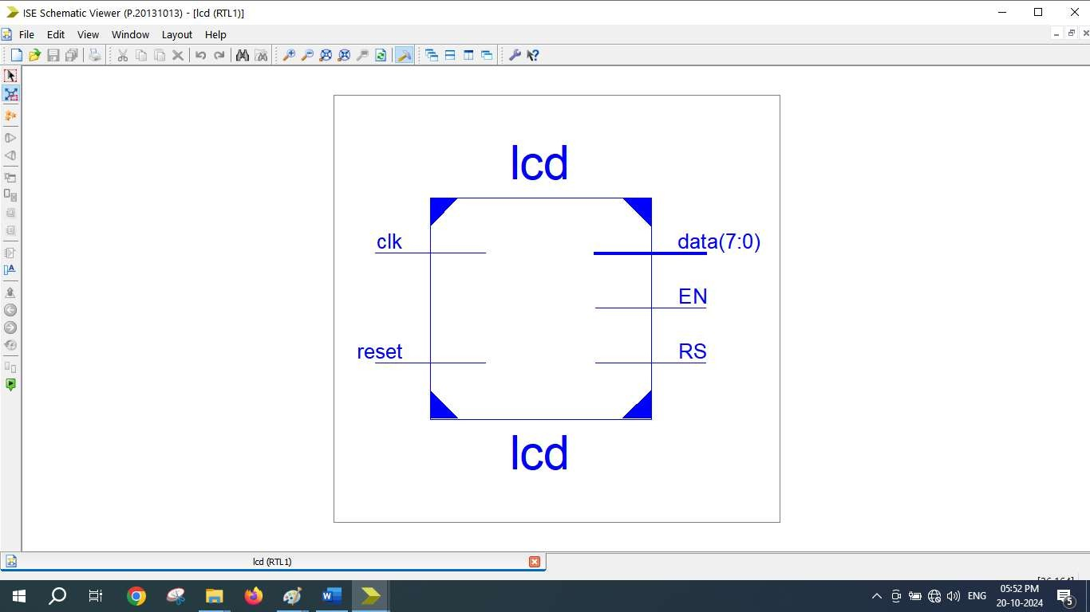

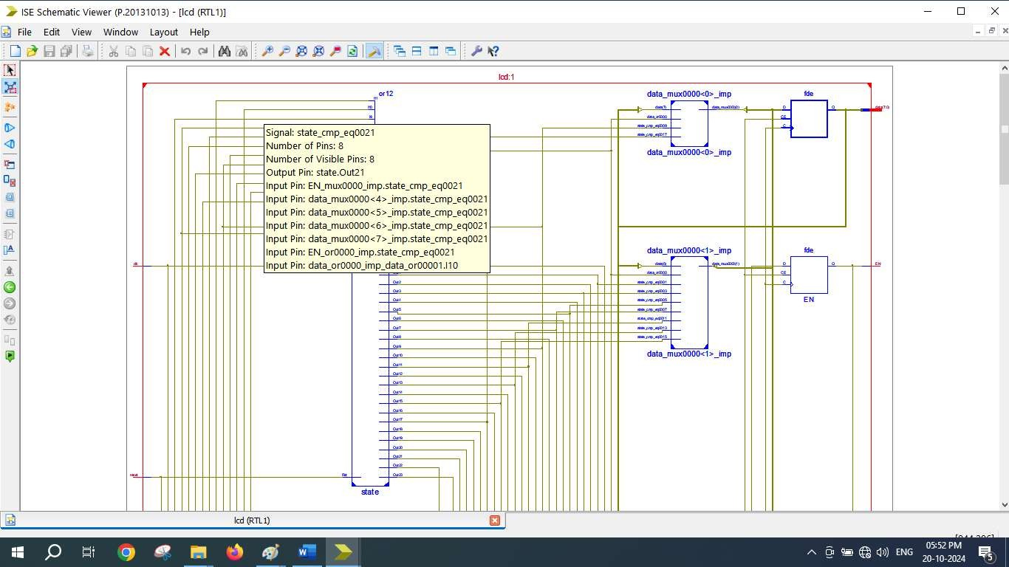

=========================================================================
* Final Report *
=========================================================================
Final Results
RTL Top Level Output File Name : lcd.ngr Top Level Output File Name : lcd
Output Format : NGC
Optimization Goal : Speed
Keep Hierarchy : No

Design Statistics
# IOs : 12

Cell Usage :
# BELS : 30
# GND : 1
# INV : 1
# LUT2_L : 2
# LUT3 : 1
# LUT3_D : 1
# LUT3_L : 3
# LUT4 : 17
# LUT4_L : 3
# VCC : 1
# FlipFlops/Latches : 34
# FDC : 22
# FDCE : 1
# FDE : 10
# FDP : 1
# Clock Buffers : 1
# BUFGP : 1
# IO Buffers : 11
# IBUF : 1
# OBUF : 10
=========================================================================

Device utilization summary:

Selected Device : 3s250epq208-5

Number | of | Slices: | 24 | out | of | 2448 | 0%
Number | of | Slice Flip Flops: | 34 | out | of | 4896 | 0%
Number | of | 4 input LUTs: | 28 | out | of | 4896 | 0%
Number | of | IOs: | 12
Number | of | bonded IOBs: | 12 | out | of | 158 | 7%
Number | of | GCLKs: | 1 | out | of | 24 | 4%

